Labor’s Early Struggle for Recognition Presentations

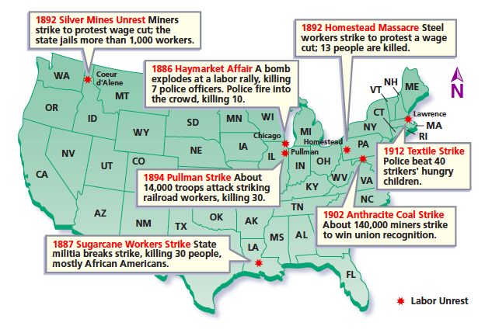
Resources:
- 1886 Haymarket Affair –
https://www.history.com/topics/19th-century/haymarket-riot

- 1887 Sugarcane Workers Strike –
https://www.smithsonianmag.com/history/thibodaux-massacre-left-60-african-americans-dead-and-spelled-end-unionized-farm-labor-south-decades-180967289/

- 1892 Silver Mines Unrest –
https://www.loc.gov/rr/news/topics/cour.html
https://www.thoughtco.com/1886-haymarket-square-riot-chicago-1773901

- 1892 Homestead Massacre –
https://www.history.com/topics/industrial-revolution/homestead-strike
https://aflcio.org/about/history/labor-history-events/1892-homestead-strike

- 1894 Pullman Strike –
https://www.britannica.com/event/Pullman-Strike

- 1902 Anthracite Coal Strike –
https://www.dol.gov/general/aboutdol/history/coalstrike

- 1912 Textile Strike –
https://www.history.com/news/the-strike-that-shook-america-100-years-ago

